Following the great tradition of the last biennium, you will again receive a newsletter for the NWR Super 16 – a publication for the 16 presidents from the Northwest Region of DKG! This newsletter, along with e-mails and the “new” DKG Website will highlight our 2015 conference and your stories of work at the chatper level in serving our members--as you share them with me. You, as leaders, guide and model the work of The Society in your chapters, your classes and your communities.
Northwest Regional Conference Watch
Regina, Saskatchewan awaits your arrival in late July—for preconference training for newly elected officers and tours (experiential learning opportunities) for attendees and guests before our great conference.
Regina is the city located closest to the geographic center of North America. It is a bustling city of over 200,000. Hotel Saskatchewan overlooks Victoria Park, close to cultural centers, restaurants and shops.
Regina, the Queen’s City invites YOU!!
July 29 to August 1, 2015!
Last week all five RD’s met in Austin, Texas. Our theme is President Lyn’s theme: 85 Years and Beyond: Advancing Key Women Educators for Life. We all accepted her challenge to “change” the conference in response to the surveys from members about what they like and don’t at our regional conferences.
An International Event
Each regional conference is sponsored by DKG International. Each conference will be unique but all will reflect the same theme and changes. If you are unable to attend the NW regional conference attend one in another region. Maybe the dates don’t fit into your schedule. Maybe you plan to visit family or friends in another area. I compared prices from my airport (MSP) for each of the regionals and their dates—prices are competitive.
Departing from Minneapolis to:
NE – Baltimore, MD July 8-11 $527.00
SE – Savannah, GA July 15-18 $506.00
SW – Wichita, KS July 22-25 $377.00
NW – Regina, SK July 29-Aug 1 $510.00
EU – Borås, SWE Aug 5-8 $1304.00

Be certain to pick one (or more) conferences and register in early 2015 when the conference registration and hotel reservations go live on the DKG webpage.

YOUR NW Regional Director is a veteran teacher with experience at the K-12 and postsecondary level, teaching Spanish, German and FL pedagogy. I had no intention to learn either Spanish or German but each has enriched my life.
I have a supportive husband--I celebrate his birthday with my DKG friends every year. I am proud of my two adult children and adore my one-year-old granddaughter.
It is my time to serve--DKG and you. 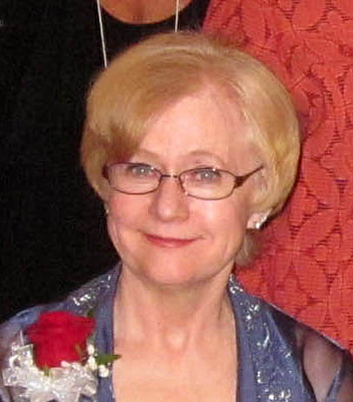

Fast fact about your NWR director…
Phylllis

